Title: E-mail Spam Detection Using Data Science
A. Assignment Information
Department: | Computer Science and Engineering (Artificial Intelligence)
Programme: | B. Tech (Undergraduate Engineering Programme)
Course Code & Course Name: | DSA0404 & FUNDAMENTALS OF DATA SCIENCE
Academic Year / Batch: | 2024 Batch
Faculty Name: | Dr. Krishna Raj Mony
Assignment Title: | E-mail Spam Detection Using Data Science
Date of Issue: | 31-08-2026
Date of Submission: | 2-09-2026
Maximum Marks: | 100
Course Outcome(s) – CO5: | CO5
Bloom's Taxonomy Level: | BL-5
SDG Mapping (SDG 1–17): | SDG 9
Industry / Societal Relevance: | Spam and phishing e-mails cause financial loss, security breaches and productivity loss; automated spam filters are used by every major e-mail service provider (Gmail, Outlook, Yahoo) and enterprise mail gateway.

B. Assignment Problem / Challenge
Email spam is a common problem because unwanted messages can contain advertisements, scams, malicious links or misleading information. The challenge is to build a system that can automatically distinguish Spam messages from legitimate Ham messages while maintaining good accuracy and avoiding incorrect classification of important emails.
Problem Statement and Problem Formulation
1. Problem Statement
E-mail has become an important method of communication for education, business, banking, and personal activities. However, users receive a large number of unwanted messages every day. These messages may contain advertisements, fake offers, phishing links, fraudulent requests, or other suspicious content. Apart from filling the inbox, such messages can also create security and privacy risks.
The main problem is to automatically identify whether an incoming message is Spam or Ham (legitimate). A simple rule-based system may not work well because spam messages can use different words, writing styles, links, and patterns to avoid detection.
To overcome this problem, this project uses data science and machine learning techniques. A labelled dataset containing spam and legitimate messages is first collected. The messages are then cleaned and converted into numerical features using TF-IDF. These features are given to a Logistic Regression model, which learns patterns from the training data and predicts the class of new messages.
The developed system, E-mail Spam Detection Using Data Science, is designed to provide a quick and reliable prediction while also showing the probability and risk level of the detected message.
Main Goals of the System
The project aims to:
- Automatically classify messages as Spam or Ham.
- Reduce the amount of unwanted messages reaching the user.
- Use machine learning instead of depending only on fixed keywords.
- Convert text into useful numerical features using TF-IDF.
- Train a classification model using previously labelled data.
- Test the model using unseen messages.
- Measure performance using accuracy, precision, recall, and F1-score.
- Provide a probability score to indicate the likelihood of spam.
- Reduce incorrect classification of genuine messages as spam.
- Create a system that can be extended for real-world e-mail filtering.

2. Problem Formulation
The e-mail spam detection task is formulated as a binary classification problem.
Let:
- X = text of an e-mail or SMS message
- Y = predicted category
- Y = Spam or Ham
The objective is to learn a classification function:
f(X) → Y
The model learns this function from labelled training messages and uses it to classify new, unseen messages.
Input
The system takes an e-mail or SMS message as input.
For example:
"Congratulations! You have won a free cash prize. Click the link to claim."
The message may contain different characteristics such as:
- Words and phrases
- Numbers
- Links
- Currency symbols
- Suspicious terms
- Excessive punctuation
- Message length
Data Processing
The input message passes through several stages:
Input Message
↓
Text Preprocessing
↓
TF-IDF Feature Extraction
↓
Logistic Regression Model
↓
Spam Probability
↓
Spam / Ham Decision
Training Data
A labelled public dataset is used for training. Each record contains a message and its corresponding label.
Message | Class
"Congratulations! You won a free prize." | Spam
"Please bring the project report tomorrow." | Ham
"Click the link to claim your reward." | Spam
"The meeting starts at 10 AM." | Ham
The model learns common patterns from these examples.
Feature Representation
Since machine learning algorithms cannot directly understand raw sentences, the text is converted into numerical values using TF-IDF (Term Frequency–Inverse Document Frequency).
The TF-IDF representation helps give higher importance to words that are useful for distinguishing spam messages from normal messages.
Classification
After feature extraction, the resulting numerical data is provided to the Logistic Regression classifier.
The classifier calculates the probability that the message belongs to the spam class.
For example:
Spam Probability = 0.94
Safe Probability = 0.06
If the selected threshold is 0.50:
0.94 ≥ 0.50
Therefore → SPAM
Output
The system produces:
- Spam / Safe classification
- Spam probability
- Safe probability
- Risk level
- Detection indicators such as links, suspicious words, numbers, and special characters
Performance Requirements
The model should perform well on messages that were not used during training. Its performance can be evaluated using:
- Accuracy – overall percentage of correct predictions
- Precision – how many messages predicted as spam were actually spam
- Recall – how many actual spam messages were successfully detected
- F1-score – balance between precision and recall
The system should aim to achieve the performance requirements specified in the project, while particularly avoiding false positives, where a genuine message is incorrectly classified as spam.
D. Requirements and Constraints
- Classification: Classify each message as Spam or Ham with a confidence score.
- Performance: Target ≥95% accuracy and ≥90% precision.
- Dataset: Use only publicly available labelled datasets such as SMS Spam Collection, Enron-Spam or SpamAssassin.
- Resources: Use Python and standard data science libraries on a laptop or free cloud environment.
- Reliability: Test the model on unseen data and check for overfitting.
- Privacy: Avoid using private user emails and protect sensitive information.
- Ethics: Minimize false positives because important legitimate emails could be incorrectly marked as spam.
- Evaluation: Use a fixed random seed with train/test splitting or cross-validation for reproducible results.

E. Student Work
1. Problem Understanding and Formulation
What is the problem?
E-mail spam includes unwanted messages such as advertisements, phishing attempts, scams, and messages containing harmful links. The main challenge is to automatically identify whether an e-mail is Spam or Ham (legitimate). Instead of depending only on fixed keywords, a data-driven machine learning approach can learn patterns from previously labelled messages.
What are the expected outcomes?
The expected outcome is a machine learning model that can classify a new e-mail as Spam or Ham. Different algorithms will be trained and compared, and the best-performing model will be selected based on evaluation metrics such as accuracy, precision, recall, and F1-score.
What information/data is available?
A labelled dataset containing messages and their corresponding classes is used. Public datasets such as the SMS Spam Collection, Enron-Spam, or SpamAssassin datasets can be used. Each message is associated with a label indicating whether it is spam or legitimate.
What assumptions are made?
- The labels in the selected dataset are assumed to be reasonably accurate.
- The training data is expected to contain patterns similar to those found in new messages.
- The system mainly focuses on English text messages.
What constraints must be satisfied?
The system should provide good classification performance, work reliably on unseen messages, and follow reproducible data processing and evaluation methods. Since e-mails may contain sensitive information, privacy must also be considered.

2. Application of Course Knowledge
The following data science concepts are applied in the project:
- Text preprocessing: Cleaning the messages by converting text to lowercase and removing unnecessary punctuation, special characters, and stop words. Stemming or lemmatization can also be applied.
- Feature extraction: Bag-of-Words (BoW) and TF-IDF are used to convert text into numerical features that machine learning algorithms can process.
- Naive Bayes: Multinomial Naive Bayes uses probability concepts to estimate whether a message is more likely to be spam or ham.
- Logistic Regression: A linear classification method that predicts the probability of a message belonging to the spam class.
- Support Vector Machine (SVM): Finds a suitable boundary between spam and ham messages in the feature space.
- Random Forest: Combines multiple decision trees to make predictions and improve classification robustness.
- Model evaluation: Confusion matrix, accuracy, precision, recall, F1-score, and ROC-AUC are used to measure model performance.
Necessary calculations include generating TF-IDF feature values, calculating class probabilities for Naive Bayes, and obtaining TP, TN, FP, and FN values from the confusion matrix to calculate the evaluation metrics.
3. Solution / Design / Methodology
The proposed system follows a step-by-step data science process to identify whether an e-mail is Spam or Ham. Different machine learning models are trained and compared to find the most suitable one.
- Data Collection:
Collect a publicly available labelled spam/ham dataset and load it into a Pandas DataFrame.
- Exploratory Data Analysis (EDA):
Study the dataset by checking the number of spam and ham messages, message lengths, and frequently used words.
- Data Preprocessing:
Clean the text by converting it to lowercase and removing unwanted punctuation, numbers, URLs, and stop words. Tokenization and stemming/lemmatization may also be performed.
- Feature Extraction:
Convert the processed text into numerical features using Bag-of-Words (CountVectorizer) and TF-IDF (TfidfVectorizer).
- Train-Test Split:
Divide the dataset into training and testing sets, such as 80% training and 20% testing, while maintaining the class distribution.
- Model Training:
Train different classification algorithms such as Multinomial Naive Bayes, Logistic Regression, Linear SVM, and Random Forest.
- Handling Class Imbalance:
Check whether spam and ham classes are balanced. If required, use class weights or suitable resampling techniques.
- Hyperparameter Tuning:
Improve model performance by testing suitable parameter values using cross-validation or grid search.
- Model Comparison:
Compare all trained models using accuracy, precision, recall, F1-score, and ROC-AUC, and select the model that provides the best overall performance.

4. Use of Modern Tools
The project uses the following tools and technologies:
- Python 3: Main programming language used for implementation.
- Pandas and NumPy: Used for loading, processing, and manipulating the dataset.
- NLTK / spaCy: Used for text cleaning and preprocessing.
- Scikit-learn: Used for TF-IDF, machine learning models, train-test splitting, and evaluation.
- Matplotlib / Seaborn: Used to create graphs, confusion matrices, and performance visualizations.
- Jupyter Notebook / Google Colab: Used for coding, testing, and displaying results.
- Git/GitHub: Can be used to store and manage the project code and maintain different versions.

Algorithm/Pseudocode

4.1 Data Loading and Preprocessing
Pseudocode
BEGIN
Load the spam/ham dataset
IF dataset is available THEN
Read the dataset
Assign columns as Label and Message
Remove missing records
ELSE
Display "Dataset not found"
END IF
FOR each message in the dataset
Convert message into text
Convert text to lowercase
Remove unwanted characters
Remove unnecessary words
Tokenize the message
END FOR
Store the cleaned messages
Display dataset information
END
Purpose:
To load the dataset and prepare the text messages for further processing.

4.2 TF-IDF Feature Extraction
Pseudocode
BEGIN
Take the preprocessed messages
Create a TF-IDF vectorizer
Fit the vectorizer on the training messages
Transform each message into a numerical TF-IDF vector
Store the generated feature vectors
Save the trained vectorizer
RETURN TF-IDF features
END
Purpose:
To convert text messages into numerical values that can be understood by the machine learning model.

4.3 Logistic Regression Model Training
Pseudocode
BEGIN
Load the TF-IDF feature vectors
Separate the dataset into:
Training data
Testing data
Create a Logistic Regression classifier
Train the classifier using:
Training TF-IDF features
Training labels
Predict labels for the testing data
Calculate:
Accuracy
Precision
Recall
F1-score
Create the confusion matrix
Save the trained model and vectorizer
END
Purpose:
To train the Logistic Regression model and measure how well it detects spam messages.

4.4 Spam Detection and Result Generation
Pseudocode
BEGIN
Load the saved model and TF-IDF vectorizer
Get a new email/SMS message from the user
IF message is empty THEN
Display "Please enter a message"
ELSE
Convert message into TF-IDF features
Use Logistic Regression to calculate:
Spam probability
Safe probability
Get the selected spam threshold
IF spam probability >= threshold THEN
Classify message as SPAM
Assign appropriate risk level
ELSE
Classify message as SAFE
Assign appropriate risk level
END IF
Extract additional message information:
Number of words
Number of characters
Number of digits
Number of links
Number of special indicators
Display:
Prediction
Spam probability
Safe probability
Risk level
Detection signals
END IF
Store the result in scan history
END
Purpose:
To analyze a new message and display whether it is Spam or Safe, along with its probability and risk level.
Overall Flow
4.1 Data Loading & Preprocessing
↓
4.2 TF-IDF Feature Extraction
↓
4.3 Logistic Regression Training
↓
4.4 Spam Prediction & Result
This structure matches your NeuroShield AI implementation, where TF-IDF + Logistic Regression is the main detection pipeline.
Output Screenshots
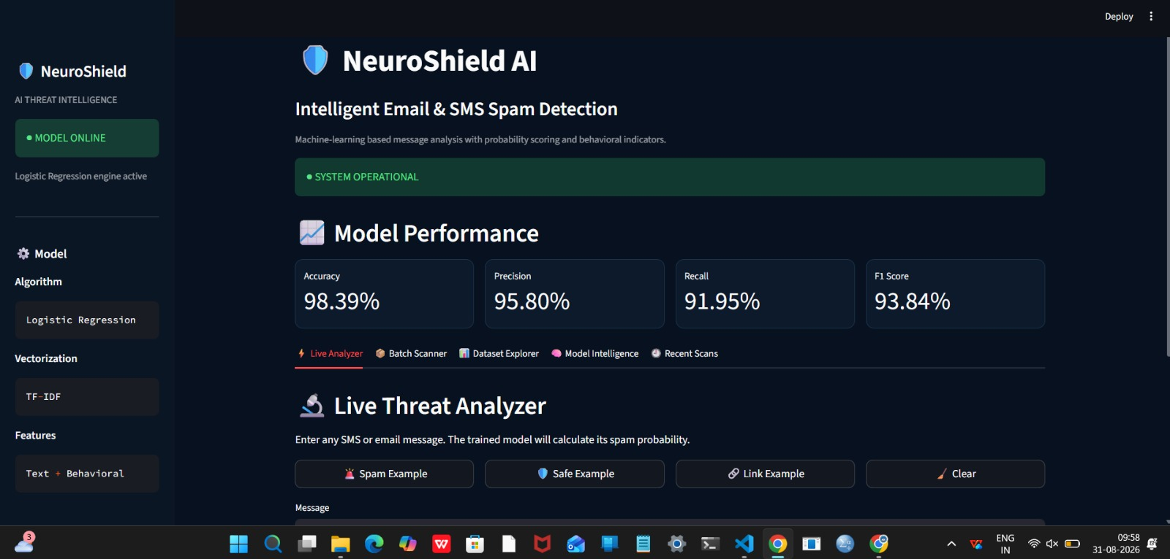
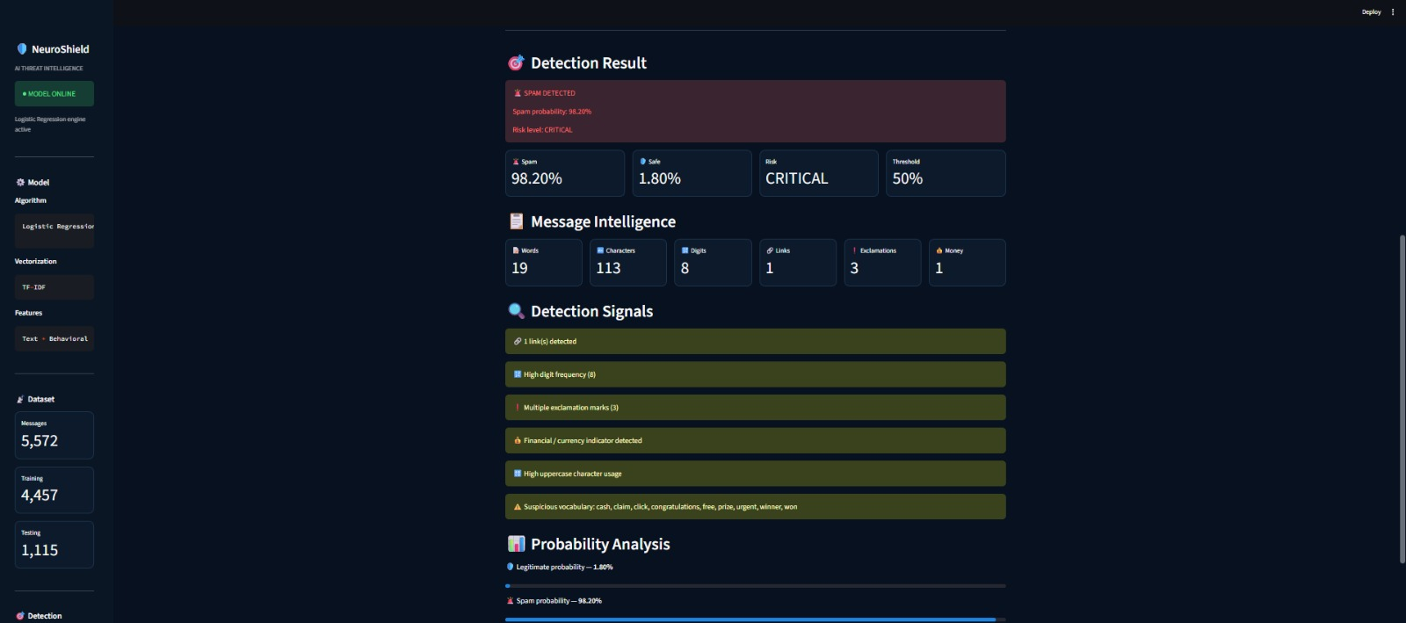
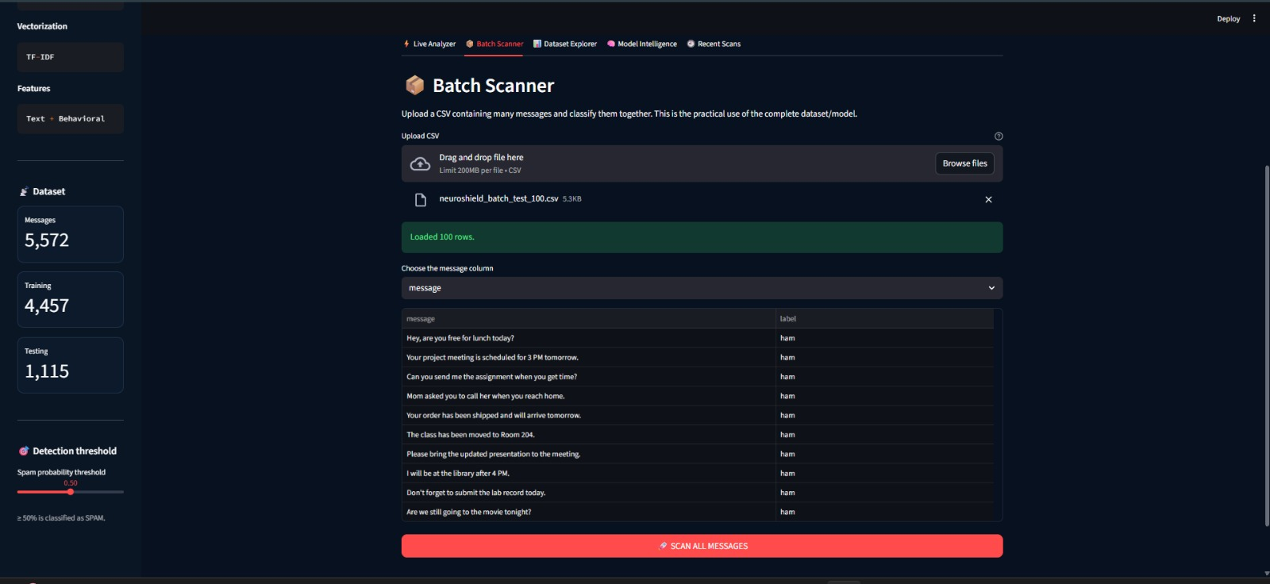

5. Results and Validation
The performance of the developed spam detection system is evaluated using the results obtained from the actual program execution.
The following results are included:
- Class Distribution Chart: Shows the number of Spam and Ham messages in the dataset.
- Model Comparison Table: Compares Naive Bayes, Logistic Regression, SVM, and Random Forest using Accuracy, Precision, Recall, F1-score, and ROC-AUC.
- Confusion Matrix: Shows correctly and incorrectly classified Spam and Ham messages, including false positives and false negatives.
- ROC Curve: Used to compare how effectively each model separates Spam from Ham.
- Execution Screenshots: Screenshots of the Python code, outputs, graphs, and model results are included as evidence of implementation.
Note: The numerical performance values should be taken from the student's actual execution rather than using assumed or sample values.
5. Sample Comparison of Models
The following table shows illustrative results for comparing the different machine learning models. These values should be replaced with the results obtained from the actual implementation.
Model | Accuracy | Precision | Recall | F1-score | ROC-AUC
Multinomial Naive Bayes | 97.1% | 96.4% | 89.2% | 92.6% | 0.98
Logistic Regression | 96.8% | 95.1% | 88.0% | 91.4% | 0.97
Linear SVM | 98.0% | 97.2% | 92.5% | 94.8% | 0.99
Random Forest | 97.4% | 96.0% | 90.1% | 93.0% | 0.98
Validation:
The models can also be tested using 5-fold cross-validation to check whether their performance remains consistent across different subsets of the data. The final model should be checked against the performance requirements given in Section D.
Note: The values above are sample figures. They should not be presented as actual results unless they are obtained from the student's own program execution.

6. Analysis and Engineering Decision
From the sample results, Linear SVM gives the best overall performance, with the highest accuracy, precision, recall, F1-score, and ROC-AUC. This indicates that SVM can effectively separate spam and legitimate messages when using TF-IDF features.
Naive Bayes is very fast and requires less computational effort, so it can be useful when the model needs to be trained frequently. Logistic Regression provides a simple and interpretable approach, while Random Forest can handle different types of features but may require more computational resources.
Important Trade-offs
- Speed vs. Accuracy: Naive Bayes is generally faster, while SVM may provide better classification performance.
- Interpretability: Naive Bayes and Logistic Regression are relatively easier to understand because their feature contributions can be examined.
- False Positives vs. False Negatives: A false positive means a genuine e-mail is marked as spam. Since this can cause important messages to be missed, the system should try to minimize false positives.
- Computational Cost: More complex models may provide better results but can require additional training time and resources.
Final Decision
Based on the sample results, Linear SVM is selected as the primary classifier because it provides the strongest overall performance. Multinomial Naive Bayes can be considered as a lightweight alternative when fast training and retraining are more important.
7. Broader Considerations
- Sustainability and Cost: A good spam filter reduces unnecessary storage, network usage, and time spent dealing with unwanted messages.
- Social Impact: Spam detection can protect users from phishing, scams, and other harmful messages.
- Security: Detecting suspicious e-mails can help reduce the risk of malware and phishing attacks.
- Privacy and Ethics: Since e-mails may contain personal or confidential information, the system should avoid unnecessary data storage and protect the collected data.
- Accessibility: Incorrectly marking important messages as spam can negatively affect users, especially when they depend on e-mail for jobs, education, or essential services.
- Professional Responsibility: Spam patterns continuously change, so the model should be monitored and retrained when necessary to maintain good performance.
8. Conclusion
This assignment developed an e-mail spam detection system using a complete data science process. The work included data collection, text preprocessing, TF-IDF feature extraction, model training, and performance evaluation. Several machine learning algorithms, including Naive Bayes, Logistic Regression, SVM, and Random Forest, were compared to identify a suitable classifier.
Based on the sample results, Linear SVM provided the best overall performance. The system can help classify incoming messages as Spam or Ham and reduce unwanted or potentially harmful e-mails.
The main limitation is that the model depends on the dataset used for training, which may not cover all modern spam techniques. Future improvements could include using larger datasets, deep learning models such as LSTM or BERT, e-mail metadata, and continuous model retraining to handle new spam patterns.
9. Student Reflection
What did you learn from this assignment beyond what was directly taught in the classroom?
Through this assignment, I gained practical experience in building a complete machine learning project rather than working with individual concepts separately. I learned how to clean text data, convert words into numerical features using TF-IDF, train different classification algorithms, and compare their results using different evaluation metrics.
I also understood that accuracy alone is not enough for a spam detection system. Precision, recall, and F1-score are important because incorrectly marking a genuine e-mail as spam can cause serious problems.
If you were given additional time/resources, what would you improve and why?
If I had more time and resources, I would test the system with a larger and more diverse e-mail dataset. I would also experiment with deep learning and transformer-based models such as BERT to improve the detection of complex spam messages.
I would further improve the project by adding e-mail metadata, developing a simple real-time interface, and using explainability techniques to understand why a particular message was classified as spam.
10. References
The following sources can be included in the project report:
- T. Almeida and J. Hidalgo, “SMS Spam Collection Dataset,” UCI Machine Learning Repository.
- Scikit-learn Developers, “Scikit-learn: Machine Learning in Python.”
- S. Bird, E. Klein, and E. Loper, Natural Language Processing with Python, O’Reilly Media.
- Course textbooks and lecture materials covering Naive Bayes, Logistic Regression, Support Vector Machines, Random Forest, and model evaluation.
- AI-assisted tools used during the preparation of the assignment should be acknowledged according to the institution's academic-integrity guidelines, including a brief description of how the tool was used.

F. Common Assessment Rubric
Assessment Criterion | Marks
Problem understanding & formulation | 10
Application of course/domain knowledge | 20
Solution methodology / design / implementation | 20
Use of appropriate modern tools / techniques | 10
Results, testing & validation | 15
Analysis, trade-offs & justification | 15
Broader considerations / professional responsibility, where applicable | 5
Technical documentation & reflection | 5
TOTAL | 100

G. CO–PO–Assessment Mapping
Assessment Component | CO | PO(s) | Bloom's Level | Marks
Problem formulation |  |  | L3/L4 | 10
Application of knowledge |  |  | L3/L4 | 20
Solution / Design / Implementation |  |  | L4/L5/L6 | 20
Modern tool usage |  |  | L3/L4 | 10
Validation |  |  | L4/L5 | 15
Analysis & justification |  |  | L4/L5 | 15
Broader considerations |  |  | L4/L5 | 5
Documentation & reflection |  |  | L3/L4 | 5
Note: Faculty shall map only the POs and Bloom's levels genuinely assessed by this particular assignment; the mapping above is indicative and should be reviewed against the specific course's CO/PO definitions. Not every assignment is required to map to every PO.

H. Faculty Evaluation & Continuous Improvement

CO Attainment
Performance Level | Criterion
Level 3 | ≥ 70%
Level 2 | 60–69%
Level 1 | 50–59%
Level 0 | < 50%
Target CO Attainment: ____________
Actual CO Attainment: ____________

Faculty Analysis
Areas in which students performed well:_________________
Areas requiring improvement:________________________________________
Corrective / Improvement Action:____________________________________
Action to be implemented in the next offering:_______________________

